# Unix

Operating System🡪 It is an interface acting between end user and hardware, we can execute command by use of operating system

## Types of Operating System🡪

1. Single user with single tasking
2. Single user with multi tasking
3. Multi user with multi tasking

* What is Unix? 🡪 Basically Unix is an operating system,with multi user with multi tasking,freely available,highly secured, work based on command. Commands are case sensitive.GUI may be or may not be available
* Versions-Red Hat,Linux,Solaris, HP,Ubuntu
* Organization🡪window10🡪 Putty terminal

We are going to practice over the virtual terminal🡪 <https://cocalc.com/app>

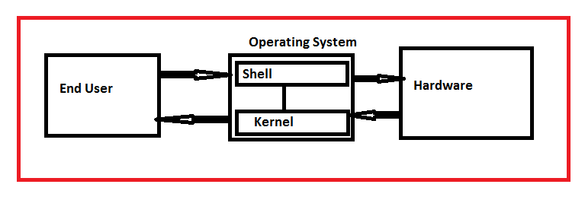

Steps need to follow🡪

1. Go to browser and open the link 🡪cocalc.com/app
2. Login with gmail/FB
3. Create project🡪give name for project
4. Upload the folder/files ( Ex-World docx, Excell, pdf,ppt, text)
5. New🡪terminal🡪create terminal

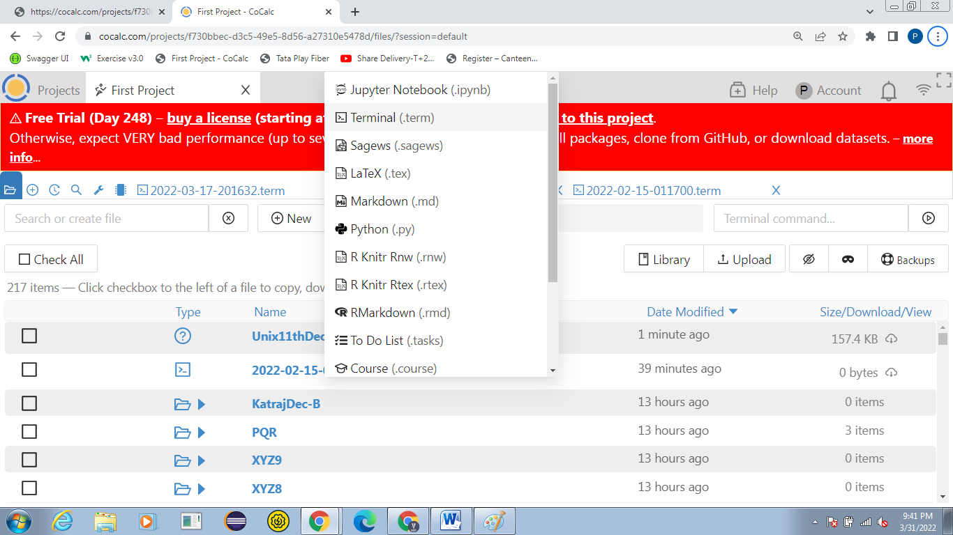

**Commands🡪**

1. ~$ **ls**🡪 use to listing of all files & directories(folders) Ex- ~$ ls

' Unix.txt' PKK9 dir45

'04-Revision-03-Vision, mission, PEO, PO, CO draft...... - Copy.docx' PKKKK dir46

1. ~$ **ls –l** 🡪 to listing of all the files/folders(directory) in present working directory (detail information will available like created date, access for file) Ex🡪 --rw-r--r-- 1 user user 22 Mar 11 02:47 ' Unix.txt'

* |-rw |-r-- |r—

File |user(u) |group(g) | others(o)

Starting with - 🡪file

Starting with d 🡪 directory

Starting with b🡪binary file

r🡪read access

w🡪 write access🡪write/edit

x🡪 Execute access🡪copy/paste/compile/delete

Ex2🡪drwx r-x r-x 3 user user 3 Jul 27 2021 1999

1. ~$ **ls –a**🡪 to view hidden files in present working directory
2. ~$ **ls –r** 🡪 to reverse order of listing of files/directories
3. ~$ **ls *.extension of file**🡪 If file name is not known but extension is known( type of file is known like word,excel,pdf,text,ppt) Ex-~$ ls *.txt
4. **Ctr+ l** 🡪 use to clear the terminal but history will be available
5. **clear** 🡪 use to clear the terminal but history won’t be available
6. **use of arrow up & arrow down**🡪to access command used in past
7. ~$ **man command name**🡪 for user manual view for particular command Ex-~$ man ls q🡪 use to move back to our terminal
8. ~$ **pwd** 🡪 use to see the present working directory
9. ~$ **cd** 🡪 use to change the directory from any where to home present working directory

~$ **cd folder/directory name**🡪 use to change the directory Ex- Administrator@PRASHANT-PC MINGW32 ~/Desktop

$ cd PQR

1. **cd ..** 🡪 use to one step move back
2. ~$ **mkdir directory name**🡪 to create new directory(folder) Ex-~$ mkdir DecEvening
3. ~$ **mkdir -p folder name/{sub folder1, subfolder2}** 🡪 to create multiple subdirectory under main directory Ex-~$ mkdir -p Month/{Jan,Feb,March,April} –p🡪 use to print process
4. ~$ **mkdir -v directory name**🡪 use to create new directory with more word like message –v🡪 Verbose🡪 use to show the action message Ex-~$ mkdir -v DecemberE mkdir: created directory 'DecemberE'
5. ~$ **mkdir directory name{1..5}**🡪 use to create multiple directories Ex-~$ mkdir Katraj{1..5} 🡪 will create Katraj1, Katraj2, Katraj3, Katraj4, Katraj5
6. ~$ **touch file name**🡪 to create new file
7. ~$ **touch file name with extension**🡪 use to create new particular document or file like-word,excel,ppt,text.pdf Ex-touch mn.pdf 🡪 it will create mn pdf file
8. ~$ **rmdir folder name**🡪 use to remove directory or folder Precondition🡪folder or directory should be empty Ex-~$ rmdir tttt
9. ~$ **rm -r folder name🡪** use to remove directory/folder which one having data Ex-~$ rm -r pp
10. ~$ **rm -rv folder name**🡪 use to remove directory having data with action message Ex-~$ rm -rv lll removed directory 'lll'
11. ~$ **rm file name with extension**🡪 use to remove particular file like word, excel,pdf Ex-~$ rm yyy.docx
12. ~$ **rm -i file name with extension**🡪 use to remove the file with confirmation message Ex-~$ rm -i Batch1.xlsx rm: remove regular file 'Batch1.xlsx'? yes
13. ~$ **rm -i file1.txt file2.txt**🡪 use to remove multiple file at time with confirmation message Ex-~$ rm -i unix.txt p.txt rm: remove regular file 'unix.txt'? no rm: remove regular file 'p.txt'? no
14. ~$ **wc file name with extension**🡪 use to display word count in particular document Ex-~$ wc 'Viman Nagar May.txt' 131 325 2432 Viman Nagar May.txt 131 |325 | 2432 | Viman Nagar May.txt No of lines |No of words | No of letters|File name
15. ~$ **head file name with extension**🡪 use to display default firt 10 line Ex-~$ head 'Viman Nagar May.txt'
16. ~$ **head -20 file name with extensiom**🡪 use to display no of lines in document Ex-~$ head -20 'Viman Nagar May.txt'
17. **I🡪Change mode🡪** Manual mode🡪 before changing access 🡪-rwxr--rwx 1 user user 46 Mar 10 03:22 p.txt rwx |r-- |rwx user(u) |group(g) |others(o) Assignment Operators🡪 + 🡪 to add access - 🡪 to remove access = 🡪 to assign same access ~$ chmod g+w p.txt🡪 to change the access for particular file or folder Ex- ~$ chmod g+w p.txt After the command🡪 -rwxrw-rwx 1 user user 46 Mar 10 03:22 p.txt Ex2🡪 ~$ chmod g=o p.txt 🡪 group will allot aces same as others **II🡪Numeric way🡪** Before changing acess🡪 -rw-rwxrwx 1 user user 46 Mar 10 03:22 p.txt rw- |rwx |rwx (u) |(g) |(o) 110 |111 |111 **421**🡪use for conversion (u) 🡪110🡪 4*1 +2*1 +1*0 =4+2+0=6 (g) 🡪111🡪4*1+2*1+1*1=7 (o)🡺111🡪111🡪4*1+2*1+1*1=7 Ex2🡪 rwx |rwx |rwx (u) |(g) |(o) 111 |111 |111 chmod 777 p.txt🡪 -rwxrwxrwx 1 user user 46 Mar 10 03:22 p.txt Ex3🡪Before drwxr-xr-x 3 user user 3 Feb 15 03:38 s rwx |r-x |rwx 🡪(u)🡪111 (g)🡪101 (o)🡪111 **421**🡪use for conversion (u)🡪4*1=2*1+1*1=7 (g)🡪4*1+2*0+1*1=5 (o)🡪 4*1+2*1+1*1=7 chmod 757 s 🡪 drwxr-xrwx 3 user user 3 Feb 15 03:38 s
18. ~$ **vi file name with extension**🡪 use to edit contain of existing file or new file or delete the content vi🡪 use to edit/delete the content Steps need to follow🡪 1.Vi file name 🡪will move to insert window 2. Press i 🡪 to go in insert mode 3.Add or edit/delete required data 4.press “ESC” to come out from insert mode 5.Shift+; 6.Press🡪wq🡪 write the change 7.Press “Enter” 🡪 will move back to our terminal
19. ~$ **cat file1 file2** 🡪 use to concatenate 2 or more files Ex- ~$ cat 'Viman Nagar May.txt' Unix.txt
20. ~$ **less file name with extension**🡪 use to see data page by page Ex-~$ less 'Viman Nagar May.txt' Steps🡪1.less file name 2.Space bar🡪 to move the next page 3.b🡪to move previous page 4.g🡪 to move first page from any where 5.Shift+g🡪to move direct last page from any where 6.q🡪 to move back our terminal
21. **more file name with extension**🡪 use to display the data page by page. Document will display in percentage Ex-~$ more 'Viman Nagar May.txt' Space bar🡪 to move next page b🡪to move back page
22. **compress file name with extension🡪** use to compress the file and file extension will get change like .Z Ex- ~$ compress 'Viman Nagar May.txt' 🡪o/p🡪 'Viman Nagar May.txt.Z'
23. ~$ **uncompress file name with extension**🡪 use to uncompress the file Ex-~$ uncompress 'Viman Nagar May.txt' ( .Z extension will remove)
24. ~$ **compress -v file name with extension**🡪 use to compress the file nd percentage of compression will display on PWD Ex-Viman Nagar May.txt: -- replaced with Viman Nagar May.txt.Z Compression: 48.58%
25. ~$ **grep "Pattern" file name with extension**🡪 use to find particular pattern in document It is working like Ctr+f Ex-~$ grep "is" 'Viman Nagar May.txt'
26. ~$ **grep -v "Pattern" file name with extension** 🡪 use to display line which do not have particular pattern Ex-~$ grep -v "is" 'Viman Nagar May.txt' 🡪 will display the line which is world not present
27. ~$ **kill process ID**🡪 use to stop the process forcefully For PID🡪 we are using command 🡪top Ex- PID=1640 , ~$ kill 1640
28. **mv source destination**🡪 use to move one folder or file from one location to another Ex-$ mv PQR Month
29. **cp source destination**🡪 use to copy the content from source file to destination file Ex-$ cp A.docx 1.docx
30. **cd/var/log**🡪 use to see the issue which is being occur in task we can see the issue is present at particular step

Git Command🡪

1. clone🡪 it is used to clone the repository from git hub to local system

Ex-$ **git clone** [**https://github.com/masterbranch/branch1.git -b branch1**](https://github.com/masterbranch/branch1.git%20-b%20branch1) 🡪 branch1 rep[ository will copy on our local machine where we have given the location so that we can import same repository in local machine

1. **Git add🡪 add the code on repository**

Ex**-$ git add src/test/java/Test_Get.java 🡪**

**git add location of file which need to commit over the git**

3.$ **git commit -m "commiting message"** 🡪 Ex-$ git commit -m "commiting mutual fund script"

**4.$ git push 🡪 script/code will successfully commeted over the branch of git hub**

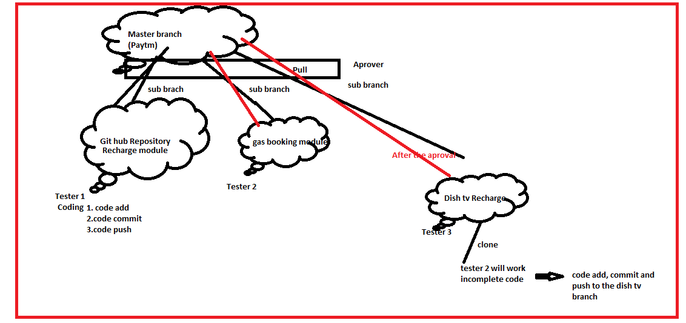

**==========================All the Best================================================**